**My Payments Plus Registration Directions**

Step1: Begin Registration

1. Go to [www.mypaymentsplus.com](http://www.mypaymentsplus.com)

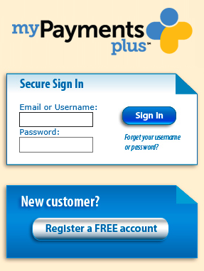

Click: Register for a FREE Account

1. Select State and institution you are going to register with:

State: PA District: Central Bucks School District

1. Select: I have a student enrolled in this district

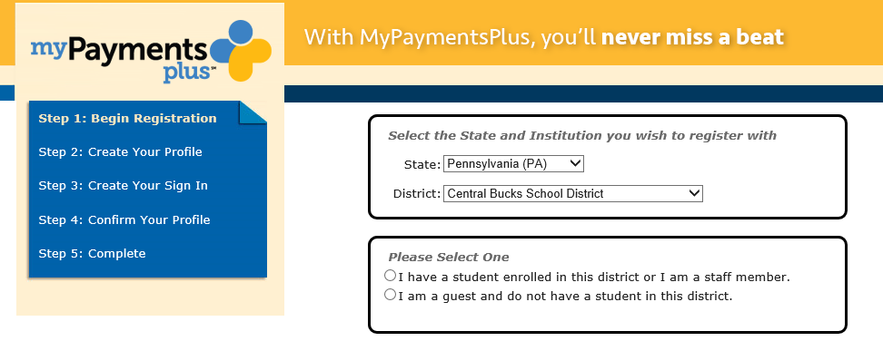

1. Add Student Information

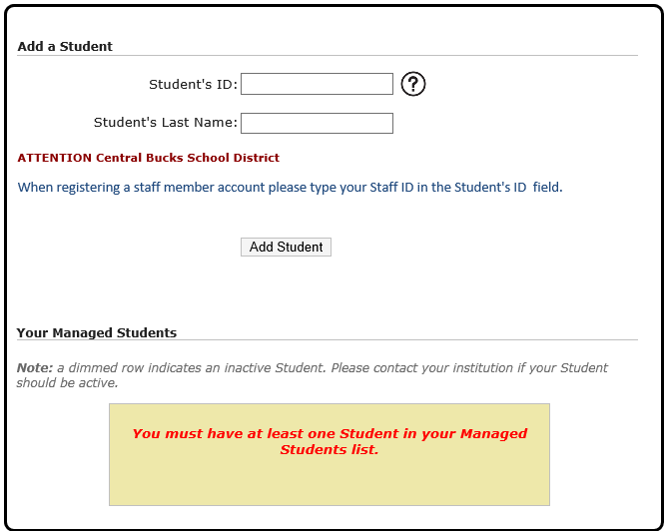

1. Once you click **Add Student**, you will be prompted to add additional students if needed
2. Click

Step 2: Create Your Profile

1. Enter required information

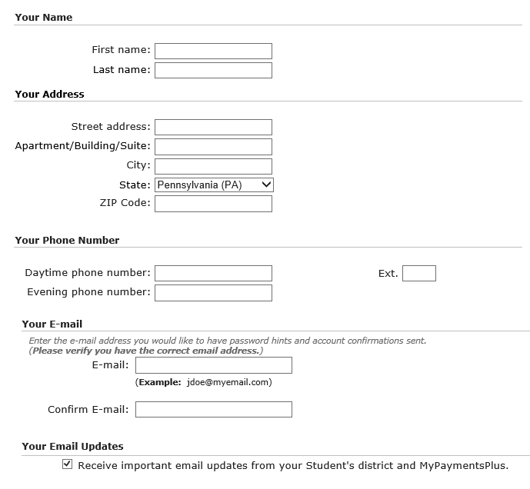

1. Click

Step 3: Create Your Sign IN

1. Enter required information

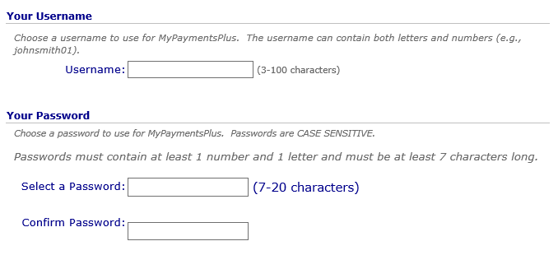

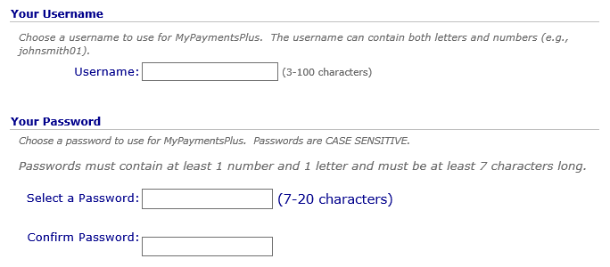

1. Click

Step 4: Confirm Your Profile

1.  Review information and **Edit** if necessary
2. Click